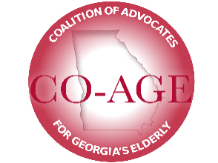
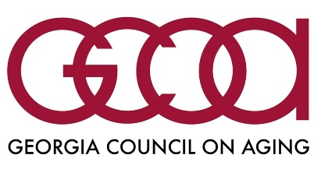
Older Adult Transportation

Over 260,000 older Georgians age 70+ have ceased driving and most of them have unmet transportation needs due to a lack of reliable, affordable, or accessible transportation. Consolidation of medical providers has increased trip distances and county transportation system boundaries have become barriers to care. Georgia’s older adult transportation services administration is fragmented, involving three state departments (DCH, DHS, GDOT), regional AAAs, and local transit authorities. Public transit is not available in 35 of Georgia’s 159 counties. GCOA believes that state-level leadership and accountability is needed to improve transit efficiency and outcomes.
In 2019, House Bill 511 was introduced to consolidate rural transit administration and funding strategies under a single agency, providing regional collaboration to better leverage existing scarce state and federal resources and developing state policies promoting innovation in mobility. This bill resulted from a two year study by the House Commission on Transit Governance and Funding. In 2018, the legislature passed HB 930, which established a new transit authority for Metropolitan Atlanta. Now with HB 511 the focus is on rural Georgia.
HB 511 would create new “Mobility Zones” throughout the state to deliver more consistent levels of service to all regions, enabling local participation in transit planning while promoting alignment with overall state plans and policy goals. HB 511 also includes new dedicated transit funding, while encouraging greater private-sector involvement and flexible delivery of transit services using tax credits and other incentive mechanisms. Its enactment can lead to integration of provider networks and growth in multi-county service delivery, improving transit coverage and operational efficiency.
HB 511 was passed in the House and now awaits action in the Senate. GCOA supports passing HB 511 in the Senate during the 2020 legislative session.

